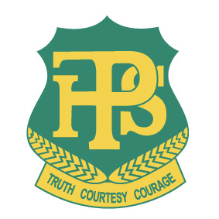
PEEL HIGH SCHOOL

Student Uniform Policy

RATIONAL:

A school uniform identifies students with a school, promotes student allegiance and pride, and also acts as a means towards providing equality amongst children, regardless of socio-economic background. School uniform identifies students both in and out of the school grounds, helping to ensure student safety.

PROCEDURES:

- The whole school community (students, parents and staff) is to determine the standards of dress for the school.

- All staff are to encourage students to wear the school uniform.

- Any significant changes to the school uniform must involve consultation with the whole school community (students, parents, staff and business community).

- The uniform is outlined below.

- Procedures to monitor the wearing of uniform include; recording inappropriate uniform on data system, Year Advisors, Head Teachers, Senior Executive and Office Staff.

- A clothing pool will be operated by the school to sell, at reasonable costs, uniforms donated to the school or acquired through ‘lost property’.

- The school will purchase and loan school blazers to students when representing the school.

- Students or parents may apply through student assistance to the Principal to purchase the school uniform.

- Students who wear non-uniform clothing to school, will be offered school uniform for the day. Students are required to return this at the end of the school day at which time, their clothing will be returned.

- Parents/Carers will be contacted to collect their student if they refuse to exchange their clothing for school uniform.

- Students who continually wear non-uniform clothing may be suspended as a result of continued non-compliance.

- The school white shirt will be worn every day except sport days on Wednesdays when students must wear their green sports shirt. Students will wear their green sports shirt during PE practical lessons but must change into their white shirts immediately after their practical lessons.

- All students leaving the school by bus in the afternoon must be in full school uniform.

- All students attending excursions/representing the school must wear full school uniform unless specifically stated on the VOR and information given to parents/carers.

- Students in Year 12 are not to wear their Senior Jerseys until their Year 12 enrolment year.

School Uniform Shop

The Peel High School Uniform Shop is open each Monday and Thursday mornings from 8.30am to 10.30am in the Administration block.

School Uniform
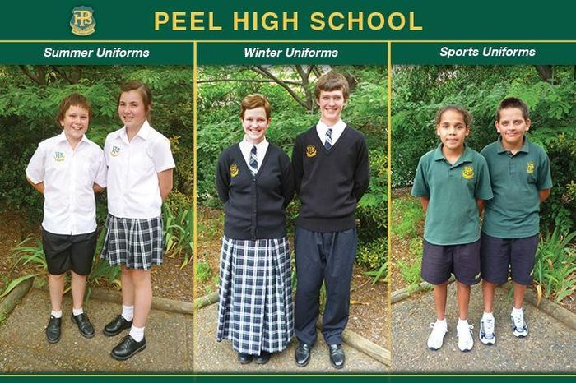
Summer Uniform
Girls: Short tartan design skirt, or black dress shorts, white cotton shirt, short white socks, black leather shoes, black knitted cardigan or jumper.
Boys: Black shorts (drill cotton), white cotton shirt, short white socks, black leather shoes, black knitted jumper.

Winter Uniform
Girls: Long tartan design skirt or black slacks (no leggings), white cotton shirt, tie, black cardigan or jumper, black stockings or white socks, black leather shoes.
Boys: Long black cotton trousers, white shirt, short black socks, black leather shoes, tie and black knitted jumper.

Note: Junior and Senior ties available for purchase from the back office.

Sports Uniform
Summer - Girls & Boys: Bottle green polo shirt with gold emblem. Black sports shorts with Peel embroidered on, white socks, joggers.

Winter - Girls & Boys: Summer uniform plus green embroidered emblem sloppy joe and plain black tracksuit pants. Peel High School tracksuit pants and jackets are also available from the School Uniform Shop.

https://detwww.det.nsw.edu.au/detresources/Footwear_Guidelines_HtaqHkzrcD.pdf

