**PEEL HIGH SCHOOL**

**YEAR 7 SELECTIVE HIGH SCHOOL OPEN DAY**

Parents and Guardians of students currently in Year 6 (2018) who are interested in our Year 7 Selective Class for 2019 are invited to attend our Open Day to share our vision for the future.

The Open Day is for Year 6 students who plan to sit for the Selective Schools Test on March 15. The morning will feature information, a tour of the school facilities, information about class size and structure, curriculum, scholarships and you will also learn about the unique opportunities available to the selective class.

Peel High School is the only co-educational school within a 100 km radius of Tamworth that is part of the state Selective School’s Network.

Refreshments will be provided by our Hospitality students and staff.

**Please come along 9.30am - 12 midday   
Saturday, March 3 2018**

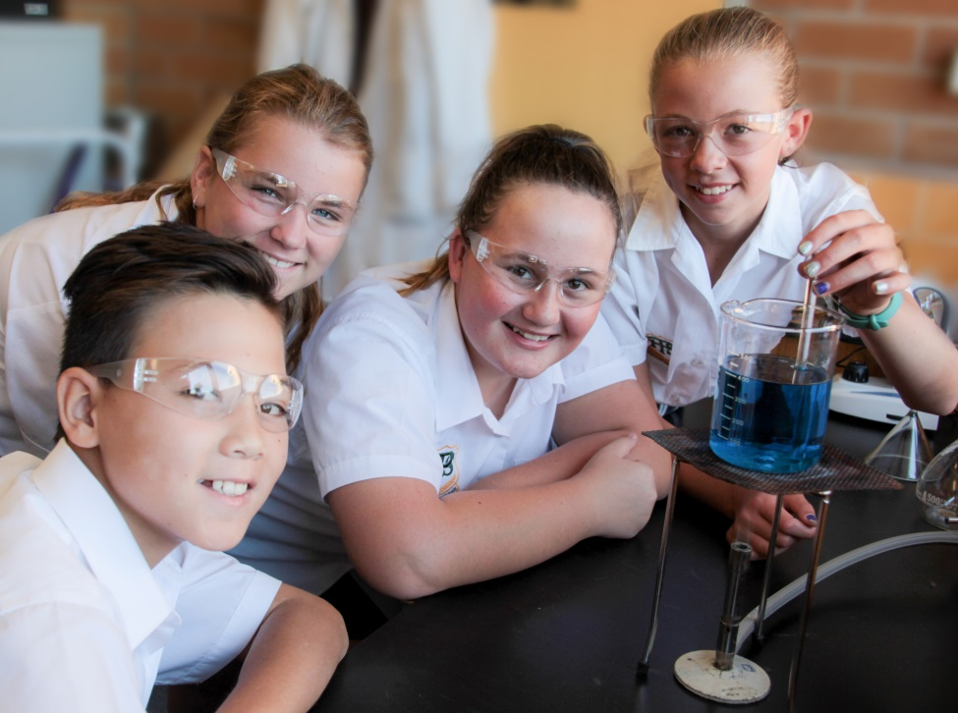

**Please RSVP by February 28 to assist with catering via the Peel High Facebook page or by contacting Kristen Miller or Lyn Stevenson on 67657088 or email Kristen on** [**kristen.miller1@det.nsw.edu.au**](mailto:kristen.miller1@det.nsw.edu.au)